LIVESTOCK REMOTE MONITORING USING MACHINE LEARNING

By, *Ramesh Dinesh Pai.*

(201104047)

DEFINING THE PROBLEM

Traditionally, farmers face challenges in closely monitoring individual livestock, leading to difficulties in early health detection and assessing overall animal welfare. To address this, an increasing number of sensors are being deployed to collect data on livestock behaviour. This project aims to leverage machine learning technique for the accurate identification of multiple unitary behaviours in livestock based on data collected from these sensors. Additionally, the project tries to implement an anomaly detection mechanism for remote monitoring, enabling early detection of improper behaviour and alerting farmers for intervention.

Project Overview:

Phase 1: Development of Machine Learning Model for Predicting Normal Behaviours.

* The initial phase focuses on creating a machine learning model capable of predicting normal behaviours exhibited by livestock.
* Leveraging data collected from livestock sensors, the model will be trained to recognize various behaviours such as sitting, standing, walking, and grazing.
* Data pre-processing techniques will be employed to enhance the model's predictive accuracy.

Phase 2: Anomaly Detection Mechanism for Remote Monitoring

* In the second phase, the project attempts to incorporate an anomaly detection mechanism to identify irregular behaviours in livestock.
* The developed model will be used to establish a baseline for normal behaviours, against which real-time data from sensors will be compared.

Expected Outcomes:

* A machine learning model capable of accurately predicting various normal behaviours in livestock.
* Attempt to develop an anomaly detection system for early identification of irregularities in livestock behaviour.

Significance:

* Improved animal welfare through remote monitoring and early detection of health issues.
* Enhanced efficiency in livestock management, allowing farmers to respond quickly to abnormal behaviour.

DATA COLLECTION

Sensor:

A livestock sensor (contains accelerometer and other sensors) was used for the purpose of collecting data. Sensor was set to lower sampling frequency (1 Hz) for extending battery life while still capturing essential information. Higher sampling frequencies consume more power.

Sensor Placement:

Choosing where to put livestock sensor is crucial because it affects the quality of the information we get. Each option has its pros and cons, and the decision depends on the project's goals. The neck is stable and good for capturing key movements. The tail is useful for emotional cues, but its movement can make readings less steady. The leg is good for specific movements but may not capture overall actions well. Deciding where to place the sensor should match the project's main goals. If it's about head or body movements, the stable neck is a good choice. In this project, for capturing various livestock behaviours, the neck provides stability and a good view, making it a reasonable pick.

Onsite Data Collection:

During the onsite data collection, the livestock sensor was attached to the neck of livestock to capture its behaviours. Due to the sensor's limited battery life, the data was captured for each individual behaviour (standing, sitting, walking and grazing) one at a time, charging the sensor between sessions. This ensured patterns for each behaviour was collected effectively, resulting in dataset of high quality.

Sample Dataset:

For now, since the livestock sensor was not developed, an online sample dataset was used for the project. The sample dataset was already labelled with behavioural labels (standing, sitting, walking and grazing). Characteristics of dataset,

* Total time duration: 17.37 hours
* Number of rows: 62540
* Number of readings for each behaviour:
  + Sitting: 11810
  + Standing: 44870
  + Walking: 18130
  + Grazing: 25490
* Number of readings falling in the intersection of behaviours: 28680

Plot of Sensor Data (m/s^2) v/s Time (sec),

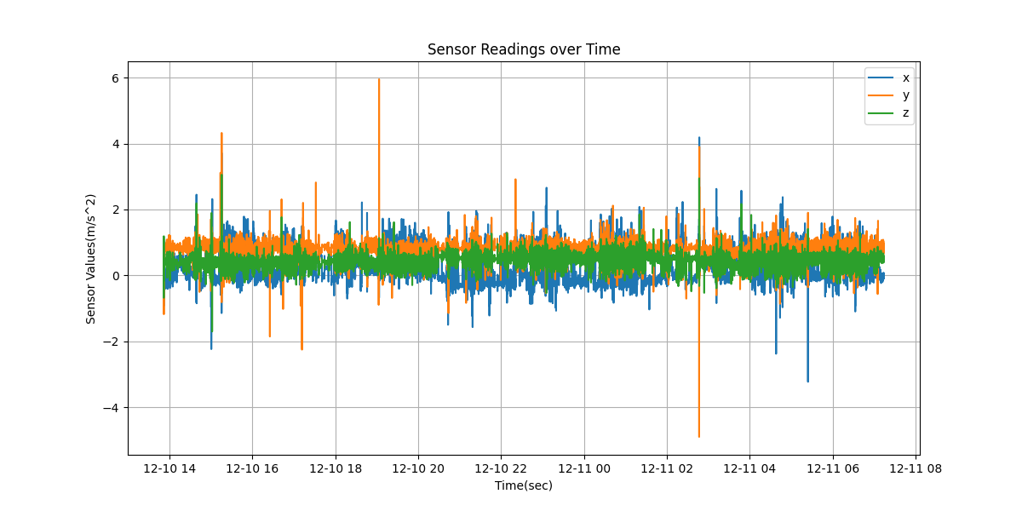

**DATA PRE-PROCESSING**

lhlkh